# TUTORIAL

## PJ

# 

## ONI JAY



Songs:

* hap (joyful)

# WEEK 1

## JAYKakashi

## 

Songs:

* Bipubeep (It Just Keeps)
* Cupid (Valentine’s Interlude)
* PIZZAWURK (Piece of Work)

# WEEK 2

## little ghost



Songs:

* ghostling
* rapture (world’s final reality)
* (woodland)

# WEEK 3

## BLRY

## 

Songs:

* Woah (Bucket)
* (Lapis Lazuli)
* ARROZ (RICE)
* (You Are My Fish)

# WEEK 4

## god

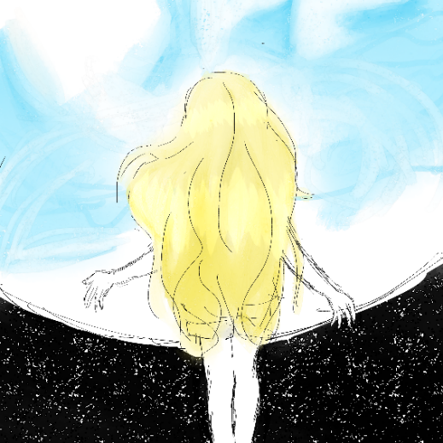

Songs:

* (god)
* (etheforma)
* Genesis (world’s first reality)

# WEEK 5

## JAYKakashi / god

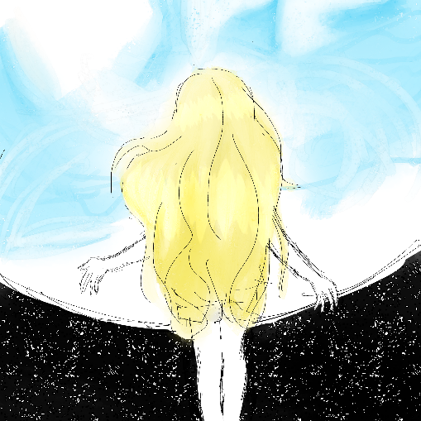

Songs:

* Soma’dios (Catchin’ Bodies / femadios)
* Lilith (FEMADIAVOLOS / Snakes)
* (intruthem / Chaos)

**WEEK 6**

## B. KYU



Songs:

* (Kyok.ee)
* Spoiled (Little Brat Interlude)
* CUTE-BYTE.EXE (Be Cute)

# WEEK 7

## Asteria

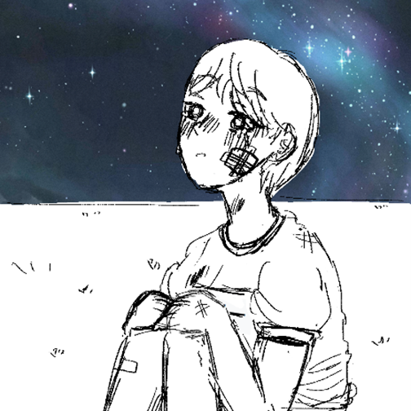

Songs:

* pain (everything hurts)
* (cyberlapse)

# FUTURE WEEK IDEAS

## Kol



## NITROUS Driver



## peeno

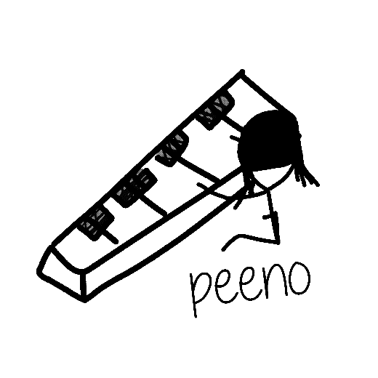

Songs:

* (peeno)
* (peeno’s big sis)
* (Purple Hill Zone 2)